- Course Code- ENCS351
- Course Name – Operating system
- Program Name: B.Tech. CSE- AI ML

- Student Name: Shubham
- Roll No. 2301730100
- GitHub Repository Link : https://github.com/shubham055555/OS-ASSIGNMENT.git












Process Creation and Management Using Python OS Module

Experiment Objectives:
- Simulate Linux process management operations using Python.

- Replicate the behaviors of fork(), exec(), and process state inspections using
os and subprocess modules.
- Understand process creation, child-parent relationships, and zombie/orphan process scenarios.

Experiment Objectives:
Understand the lifecycle of processes in Linux.
Create child processes and execute system commands using Python. Simulate zombie and orphan processes.
Inspect running processes using /proc. Demonstrate priority setting via nice values.

Concepts Used:
os.fork(), os.getpid(), os.getppid()
os._exit(), os.wait(), os.nice() subprocess.run(), os.execvp()
Reading /proc/[pid]/status, /exe, and /fd

Task 1: Process Creation UtilityWrite a Python program that creates N child processes using os.fork(). Each child prints itsPID, Parent PID,custom message . The parent waits for all the children using os.wait() :

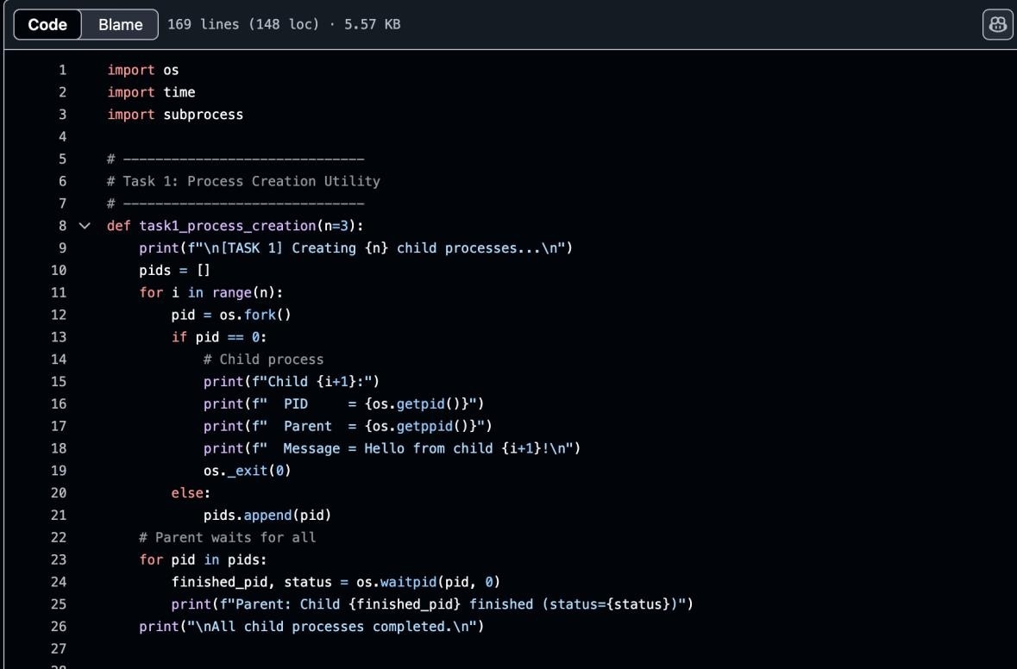

Task 2: Command Execution Using exec()
Modify Task 1 so that each child executes a Linux command (ls, date, ps, etc.) using os.execvp() or subprocess.run().

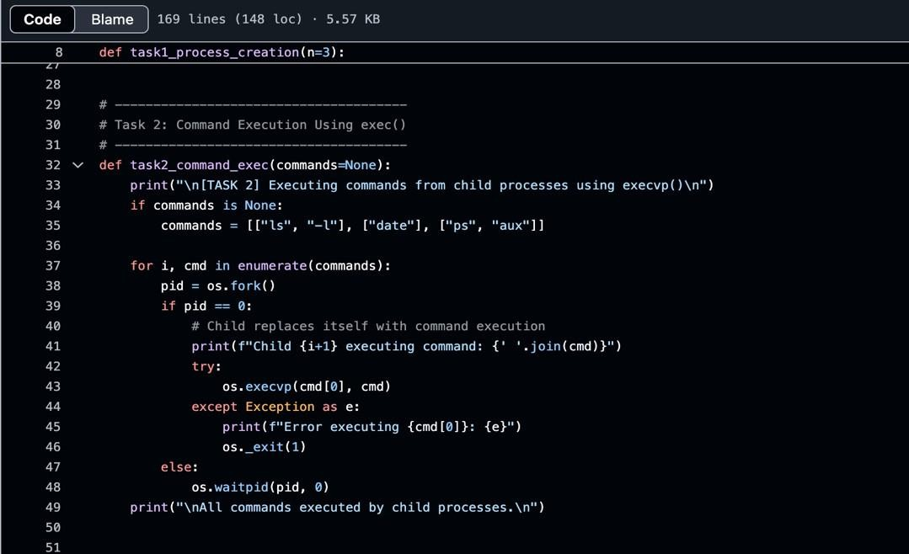

Task 3: Zombie & Orphan Processes
Simulate zombie and orphan processes. Zombie: Fork a child and skip wait() in parent. Orphan: Parent exits before child finishes. Use ps -el | grep defunct to identify zombies.
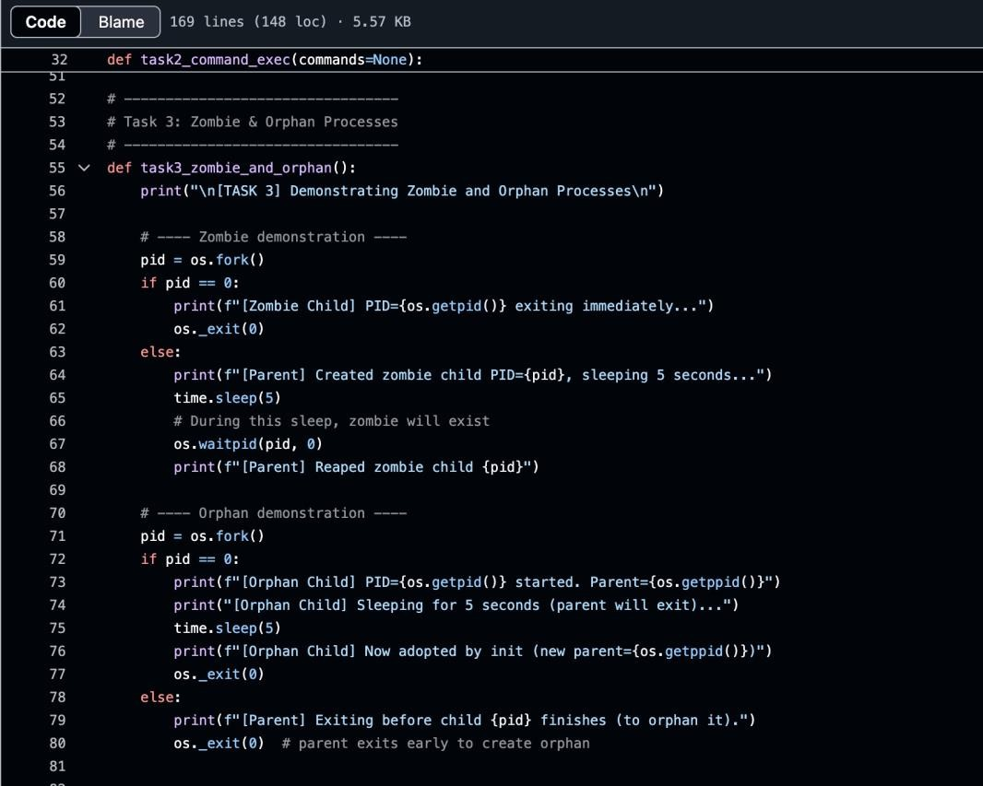

Task 4: Inspecting Process Info from /proc
Take a PID as input. Read and print process name, state, and memory usage
from /proc/[pid]/status; executable path from /proc/[pid]/exe; open file descriptors from /proc/[pid]/fd.
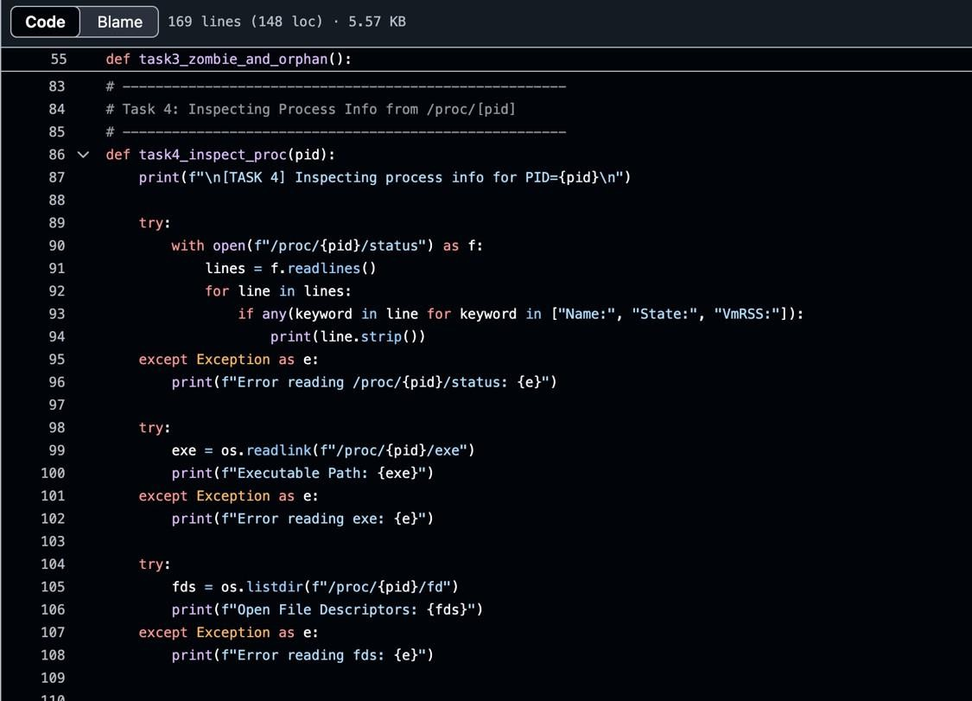

Task 5: Process Prioritization
Create multiple CPU-intensive child processes, assign different nice() values, and observe execution order to demonstrate scheduler impact.

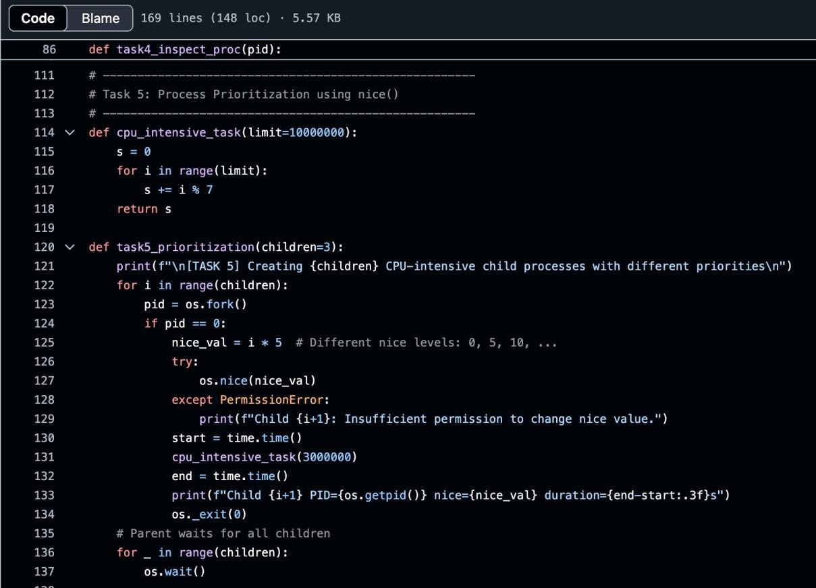

OUTPUT :
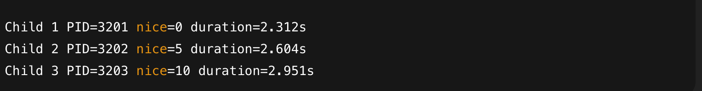
Task 1 :

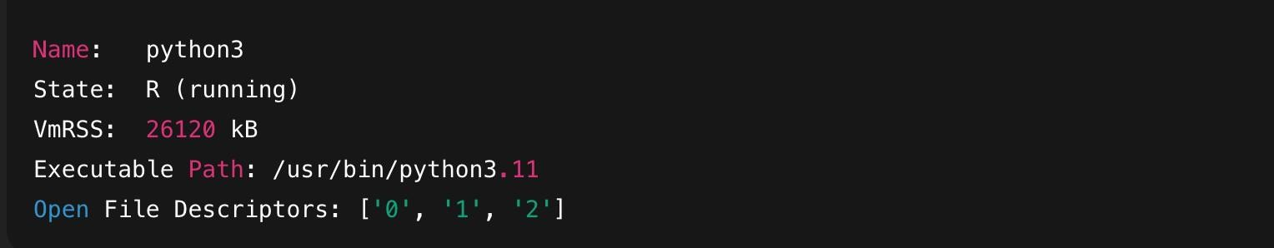
Task 2 :

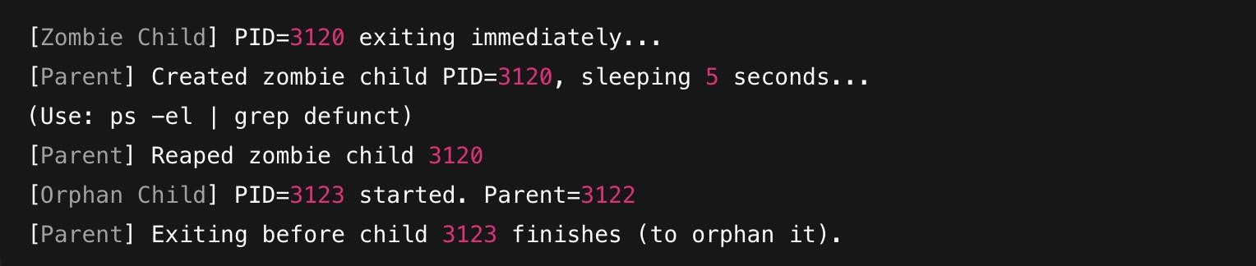
Task 3 :

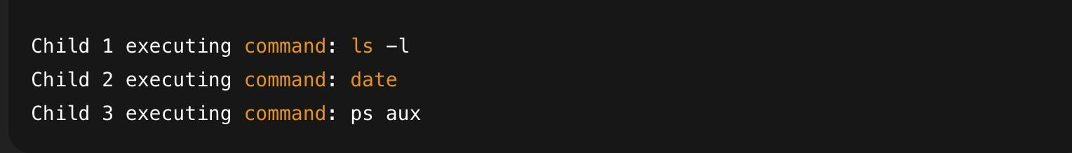
Task 4

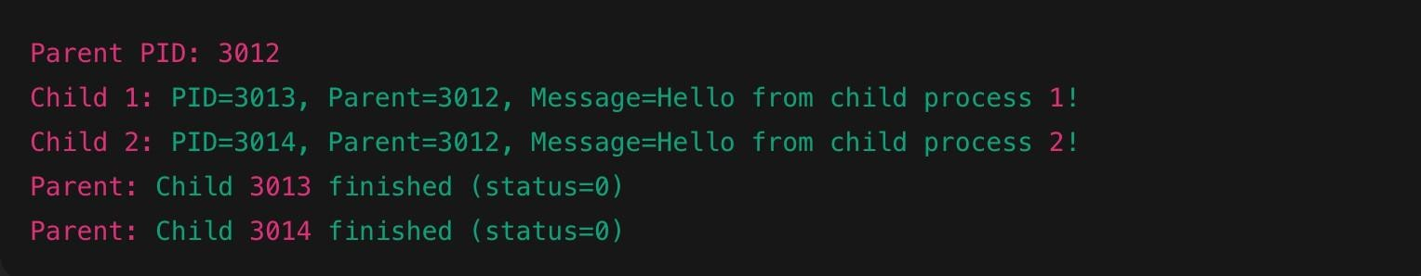
Task 5

